Unit 1 Test Name: ______________________________
___/35
page 1

___/6
Circle.

1. | 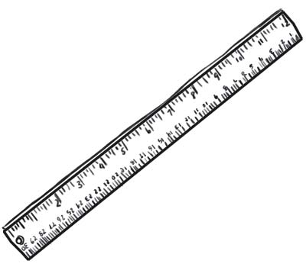 | (A) | backpack | 2. | 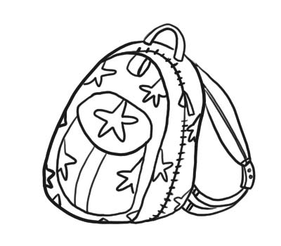 | (A) | book
 |  | (B) | ruler |  |  | (B) | eraser
 |  | (C) | pen |  |  | (C) | backpack
 |  | (D) | eraser |  |  | (D) | desk
3. | 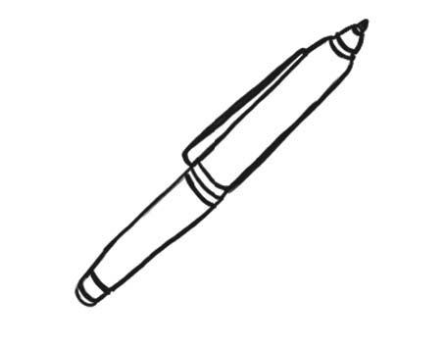 | (A) | pencil | 4. | 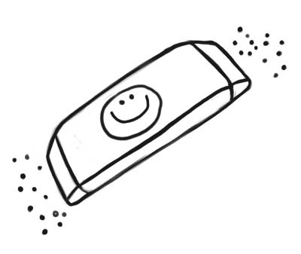 | (A) | notebook
 |  | (B) | pen |  |  | (B) | pencil case
 |  | (C) | desk |  |  | (C) | book
 |  | (D) | ruler |  |  | (D) | eraser
5. | 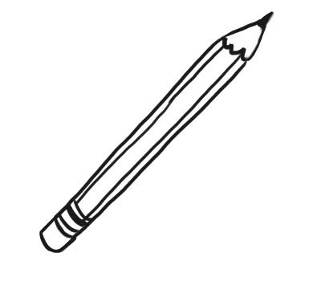 | (A) | pencil | 6. | 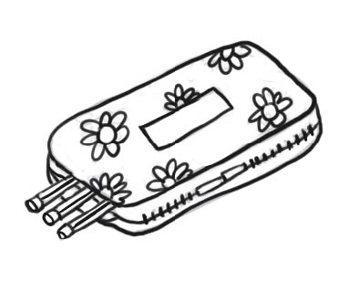 | (A) | backpack
 |  | (B) | pen |  |  | (B) | pencil case
 |  | (C) | pencil case |  |  | (C) | ruler
 |  | (D) | ruler |  |  | (D) | pencil
___/8
 | Read and write
isn’t isn’t chair notebook What it desk eraser
1. | 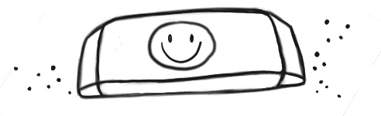 | It’s an ____________
2. | 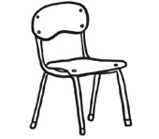 | It’s a _____________ It _____________ a desk.
3. | 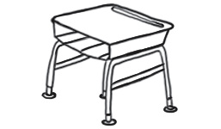 | _____________ is it? It’s a _____________
4. | 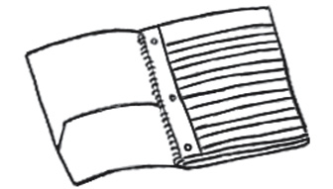 | What is _____________
4. |  | It’s a _____________ It _____________ a book.

Unit 1 Test Name: ______________________________
page 2

 | Listen and write.  good you I’m How  ___/4

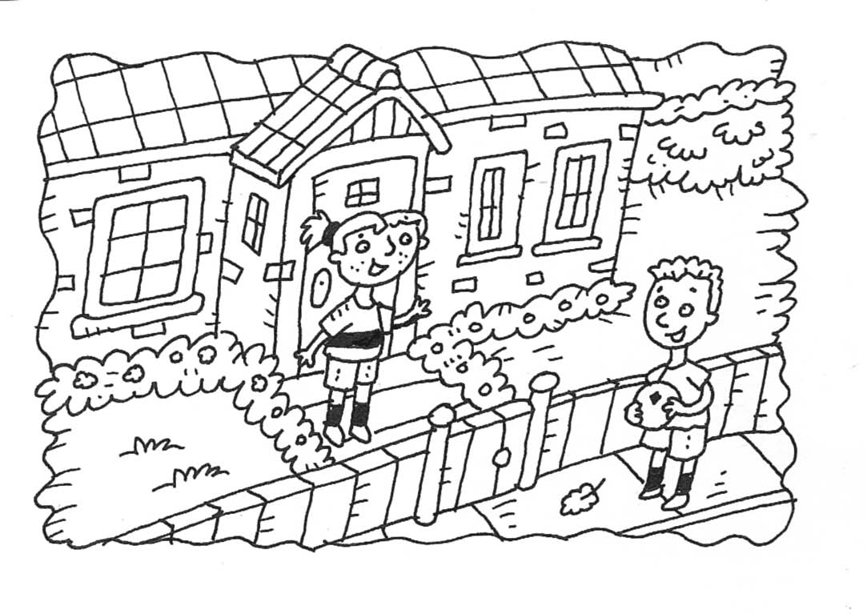 |  |  |  |  | 1. | 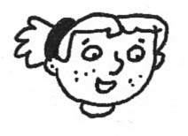 | How are _________
 |  |  |  |  | 2. | 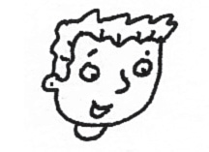 | I’m _________
 |  |  |  |  | 3. | 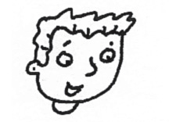 | _________ are you?
 |  |  |  |  | 4. | 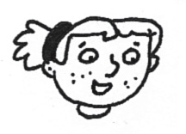 | _________ great!  ___/4
 |  | Connect.
1. |  |  | 2. | 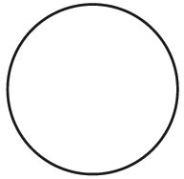 | 3. | 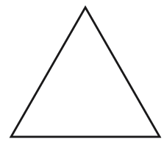 |  | 4. | 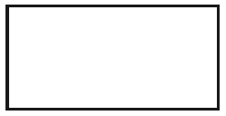
 | • |  |  | • |  | • |  |  | •
 | • |  |  | • |  | • |  |  | •
 | circle |  |  | square |  | rectangle |  |  | triangle
___/13
 |  | Read and write.
1. |  |  | Is this a circle? ________, ________ ________
2. |  |  | Is this a triangle? ________, ________ _______
3. |  |  | ________ ________ ____ ________ Yes, it is.
4. |  |  | ________ ________ ____ square? No, it isn’t.

