___/26
Unit 2 Test Name: ______________________________
page 1

___/6
 | Circle.  ___/6

1. | 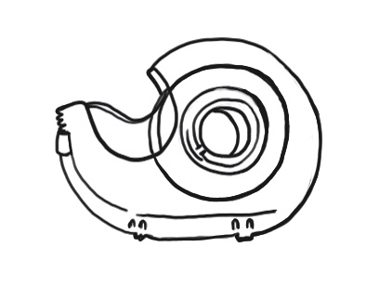 | (A) | glue |  | 2. | 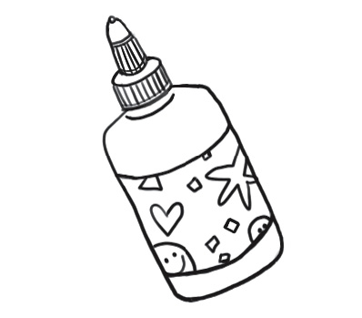 | (A) | glue
 |  | (B) | chalk |  |  |  | (B) | tape
 |  | (C) | paper |  |  |  | (C) | chalk
 |  | (D) | tape |  |  |  | (D) | paint
3. | 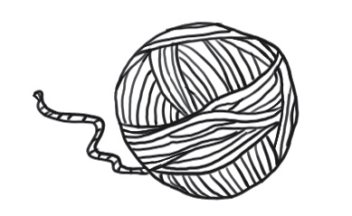 | (A) | chalk | 4. |  | 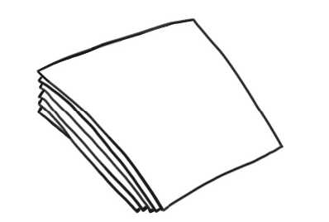 | (A) | paint
 |  | (B) | paint |  |  |  | (B) | glue
 |  | (C) | yarn |  |  |  | (C) | tape
 |  | (D) | tape |  |  |  | (D) | paper
5. | 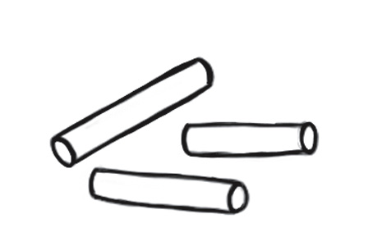 | (A) | paper | 6. |  | 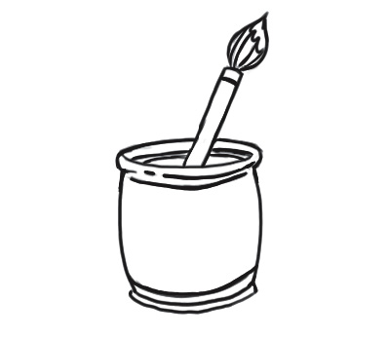 | (A) | paint
 |  | (B) | chalk |  |  |  | (B) | paper
 |  | (C) | yarn |  |  |  | (C) | yarn
 |  | (D) | tape |  |  |  | (D) | tape  ___/4

 | Read and circle.
1. | What color is it? It’s _______. |  |  | 2. | What color is it? It’s _______.
 | 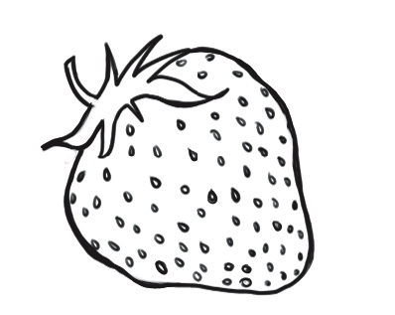 | (A) | white |  | 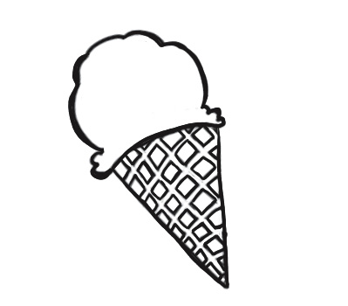 |  | (A) | blue
 |  | (B) | blue |  |  |  | (B) | white
 |  | (C) | red |  |  |  | (C) | yellow
 |  | (D) | yellow |  |  |  | (D) | green
3. | What color is it? It’s _______. |  |  | 4. | What color is it? It’s _______.
 | 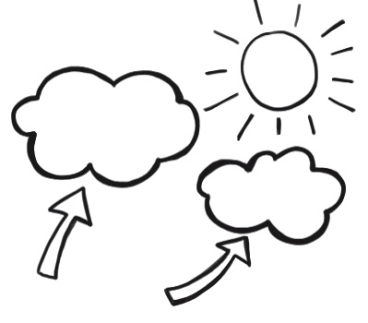 | (A) | white |  | 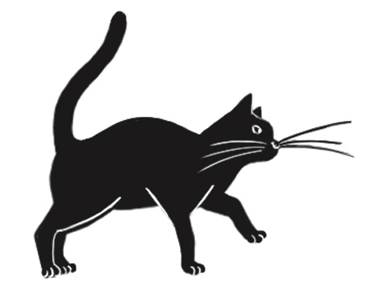 | (A) |  | white
 |  | (B) | red |  |  | (B) |  | black
 |  | (C) | yellow |  |  | (C) |  | blue
 |  | (D) | black |  |  | (D) |  | red

Unit 2 Test Name: ______________________________
page 2
___/4
 | Write.  Let’s share red my
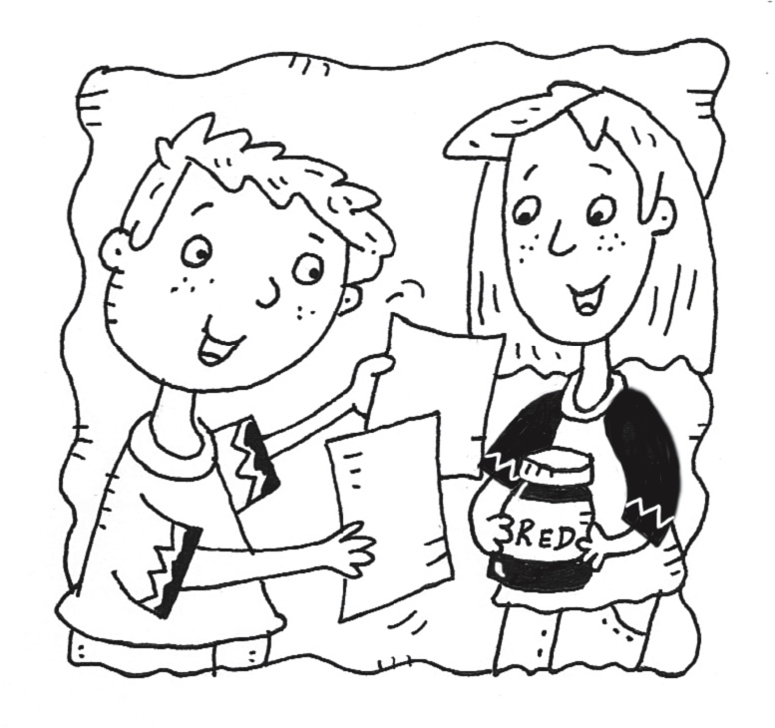 |  | 1. | 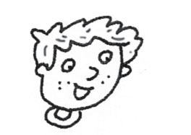 | This is __________ paper.
 |  | 2. | 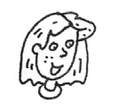 | This is my __________ paint.
 |  | 3. | 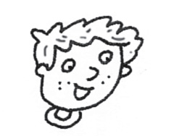 | Let’s __________
 |  | 4. | 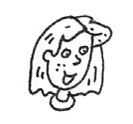 | OK. __________ share.

 |  | Listen and color. |  |  |  |  |  | ___/4
1. | 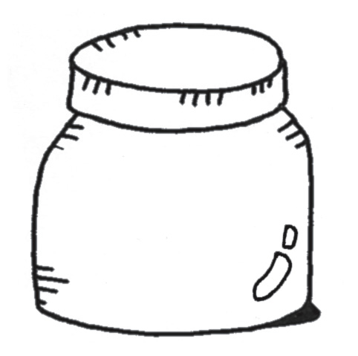 |  | 2. |  | 3. |  | 4.

 |  | Read and color.  purple yellow make white red |  |  |  |  | ___/8
 | 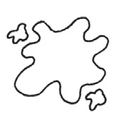

1. | Red and ______ make pink. |  |  |  |  | 2. | Blue and ______ make green.
3. | Red and yellow ______ orange. |  |  |  |  | 4. | Blue and red make ______

